Chapter 7, Problem 68.

Obtain v_{o} for t > 0 in the circuit of Fig. 7.133.

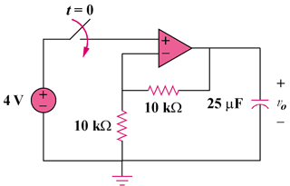

Figure 7.133
For Prob. 7.68.

